The Diamond is Forever By: Molly Hayes
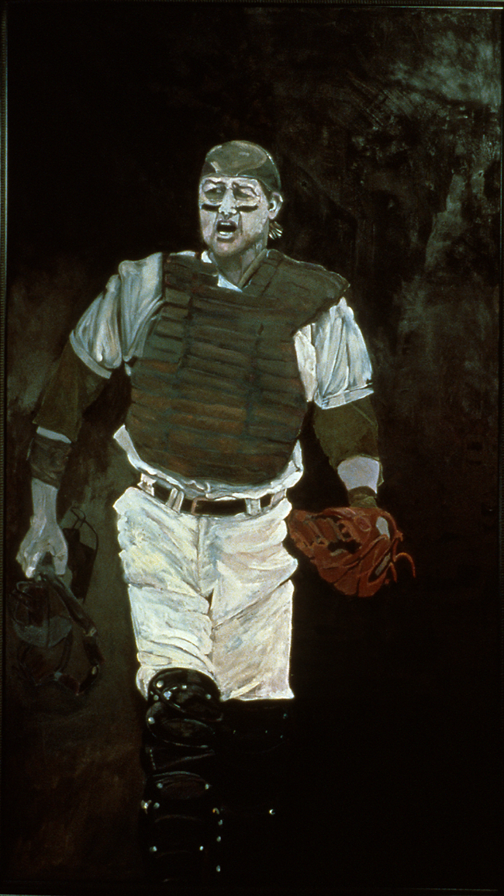
Figure 1: Susan Miller-Havens, Carlton Fisk, 1993, Oil on Cotton Duck, 83 5/8 x 48 ½. National Portrait Gallery, Champions

“A tenacious competitor with an impressive work ethic, Carlton Fisk was one of major league baseball’s most capable and durable catchers.”

Baseball has been bringing people together for decades. Grandparents, parents, and children share a common interest through baseball. In early days, radio was the only form of broadcasting and some households would leave the game on during various tasks. Susan Miller-Havens, the artist of the portrait, Carlton Fisk [Figure 1] is located in the National Portrait Gallery. The portrait was painted in 1993, the year Fisk retired from baseball. The medium is oil on cotton duck and the artwork size is 83 5/8 x 48 1-1/2. Cotton Duck is linen canvas and a durable fabric that is used for furniture, shoes and a variety of other goods.

The influence of playing baseball and listening to it on the radio gave inspiration to Miller-Havens to paint baseball players. Miller-Havens said, “It [baseball] was part of the fabric of our lives.”

Facts for viewing

The form of Carlton Fisk is a full-body portrait, placed in an asymmetrical composition. Miller-Havens uses a monochromatic color scheme which is primarily using one color and adding white and black to create light and dark areas or values and exaggerates the color through high contrast. Artists use high contrast to create intensity. Figure 2 reinforces these elements and principles of design.

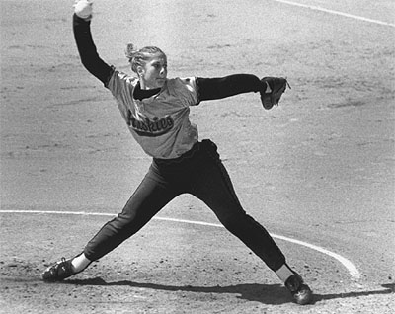
Figure 2: Max Waugh, b. 1976 Washington Softball Player Jennifer Spediacci. Photograph

Miller-Havens created twelve Fisk portraits and believed that you do not truly begin to explore an object until you have studied it repeatedly. Miller-Havens writes:

I mean to render the individual male athlete as possessor of masculinity but also as possessor of a unique personality vulnerable to all of life’s demands. They [12 Fisk Portraits] represent an attempt to re-capture the Greek appreciation for the beauty of athletic games while incorporating my understanding of what it is like to be a human being.

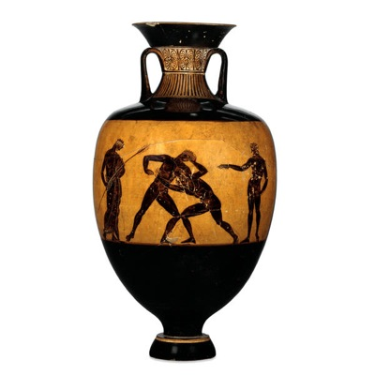
Similar to today, the Greeks considered an athlete who won major competitions to be famous. If an athlete won the competition, they would bring honor to themselves, their families, and their city-states. Figure 3 gives an example of how vases were decorated with the scenes of competitions that celebrated a number of athletic victories.
Figure 3: Kittos potter, c. 367-366 B.C.Panathenaic prize Amphora
Ideas Worth Pursuing Across Cultures and Time Periods

A moment caught in time creates a theme that connects to photography. In Miller-Haven’s artist statement, she talks about ‘creating a sense of ambiguity and timelessness that comment on human interaction.’ When referring to Fisk, Miller-Havens said, “He (Fisk) embodies fiercely and darkly the American ethic of hard work, honesty, and pride that it is so easy for society and baseball to forget.” Other athletes who also exemplify these values are Jesse Owens, Michael Jordon and Lance Armstrong.

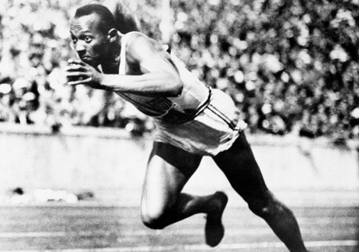
Figure 4: Photograph by the Associated Press, Jesse Owens, 1936. Photograph, Berlin

Jesse Owens was a man who in the face of doubt proved himself capable of overcoming odds. He represents pride. National geographic wrote:

“American track-and-field star Jesse Owens (seen here [figure 4] in a qualifying heat) won four gold medals at the 1936 Olympics in Berlin, including one for the 200-meter run. Owens's dominant performance was an embarrassment to Adolf Hitler, who had hoped to use the Olympics to showcase Aryan supremacy.”

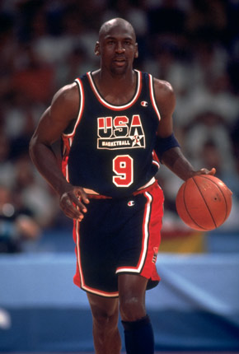
Figure 6: Barcelona 29 July 1992, Games of the XXV Olympiad. United States - Germany: American Michael Jordan in action. Getty Images

Michael Jordan [Figure 6] shows a man who never gave up. He was originally cut from the basketball team his sophomore year in High School. He practiced tirelessly and it paid off. Jordan received a basketball scholarship from North Carolina University. He went on to play for the Chicago Bulls and received many awards including two Olympic gold medals in 1984 and 1992.

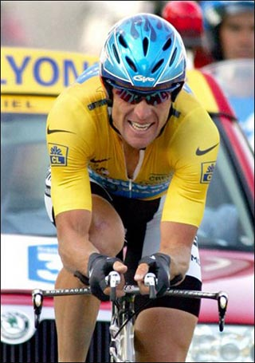

Figure 5: Kevin Liebl, 2009, Lance Armstrong, Photograph.
Lance Armstrong [Figure 6] shows a man who defeated odds and pushed forward. He is considered a leader, a teacher and an athlete. He represents life and its vulnerability. Armstrong overcame cancer and then won the Tour de France seven times.

Sports build bridges between the generations. Because athletes are timeless, people of all ages who appreciate sports can connect. The combination of sports and art exist beyond Carlton Fisk. Check the National Portrait Gallery for the exhibit “Champions” and check with your local museum for exhibits on sports artwork.

Activities Worth Doing

An activity worth doing is getting a group together at a park, gym, family house and play a sport i.e. baseball, basketball, soccer, bike-riding etc. Ask friends, family members, and/or neighbors to start a game or activity of choice.
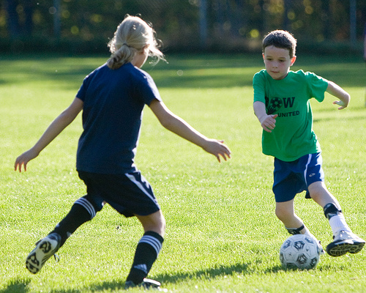
Figure 7: Flickr Ceative Commons, Soccer Kids, September 2009, Photograph.

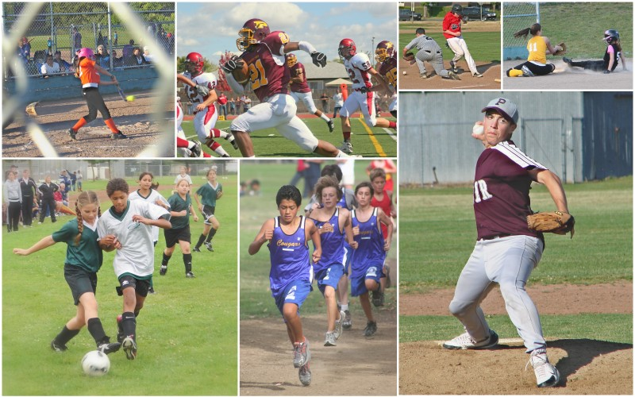
Create a collage of a sport that you like. Think about why you like this sport. Collect belongings that represent the sport like ticket stubs, player cards, programs, and newspaper clippings. Arrange objects on a piece of paper or board and glue the objects.

Figure 8: Tom Kearns, 2008, Youth Sports, Photograph.

What is your favorite sport? Team? Athlete? Why? Ask friends and family the same questions to make a connection. See if there are similarities or differences.

Figure 9: Family Talking, 2009, Photograph

Miller-Havens, S. (Artist). (2009). Carlton fisk. [Web]. Retrieved from http://face2face.si.edu/my_weblog/2009/06/portrait-of-carlton-fisk-by-susan-miller-havens.html
Portrait of carlton fisk by susan miller-havens. (2009, June 9). Retrieved from http://face2face.si.edu/my_weblog/2009/06/portrait-of-carlton-fisk-by-susan-miller-havens.html
www.wisegreek.com/what-is-cotton-duck.htm
Miller-Havens- Why I Painted Baseball
Waugh, M. (Photographer). (2010). Washington softball player jennifer spediacci. [Web]. Retrieved from http://www.maxwaugh.com/bw98/softball.html
Source: Athletics in Ancient Greece | Thematic Essay | Heilbrunn Timeline of Art History | The Metropolitan Museum of Art
Gill, N.S. (Photographer). (2010). Panathenaic prize amphora, by the potter kittos - black figure. [Web]. Retrieved from http://ancienthistory.about.com/od/greekpottery/ig/Greek-Pottery---Athletics/Panathenaic-Prize-Amphora.htm
Miller-Havens paper “An Ode to Manet- Captain C. Fisk II”
Associated Press, . (Photographer). (2009). photo gallery: olympics winner. [Web]. Retrieved from http://photography.nationalgeographic.com/photography/photos/olympics-winners-circle/jesse-owens.html
Associated Press, . (Photographer). (2009). photo gallery: olympics winner. [Web]. Retrieved from http://photography.nationalgeographic.com/photography/photos/olympics-winners-circle/jesse-owens.html
Michael jordan. (2007, July 27). Retrieved from http://www.chinadaily.com.cn/olympics/2007-07/27/content_6003100.htm
Michael Jordan. (2010). Nba encyclopedia playoff edition. Retrieved (2010, May 3) from http://www.nba.com/history/players/jordan_bio.html
Liebl, K. (Photographer). (2009). Lance armstrong. [Web]. Retrieved from http://kevinliebl.wordpress.com/2009/07/04/business-lessons-we-can-learn-from-lance-armstrong/
Martin, E.T. (2009). Lance armstrong timeline . Retrieved from http://www.infoplease.com/spot/lancearmstrongtimeline.html
Flickr , C.C. (Photographer). (2009). Family sports day. [Web]. Retrieved from http://www.thebeijinger.com/blog/2009/09/18/Calling-all-Kids-Family-Sports-Day
Kearns, T. (Photographer). (2008). Youth sports. [Web]. Retrieved from http://imageartbythomaskearns.com/
Family talking. (2009). [Web]. Retrieved from http://pubs.niaaa.nih.gov/publications/MakeADiff_HTML/makediff.htm

